|  |  |
| --- | --- |
| Functional Requirements | Non-functional Requirements |
| The touch screen system will allow the user to interact with the display by touching the overlay. | Monitor display is still clear when the touch screen overlay is placed over it. |
| The touch screen system will indefinitely poll the interface by constantly toggling the emitting diodes in sequence and monitoring the sensors. | The presence of visible light has minimal effect on the operation of the touch screen. |
| The touch screen system will store the lines that in the case where a sensor does not detect an Infrared emitter. | Scalable: if more hardware is available, the hardware design and algorithms are easily adapted for more components. |
| The touch screen system will apply a cursor action on the Operating System when a valid interception is determined from 2 lines. | Portability: Attachable and detachable overlay. |
| The touch screen system will differentiate between different cursor actions, like dragging and clicking. | Minimal delay applying the action to the OS. |
|  | Minimal display coverage of 22 inches. |

Kiosk Supplementary Document

Table 1: Functional and non-functional Requirements for the touch screen system

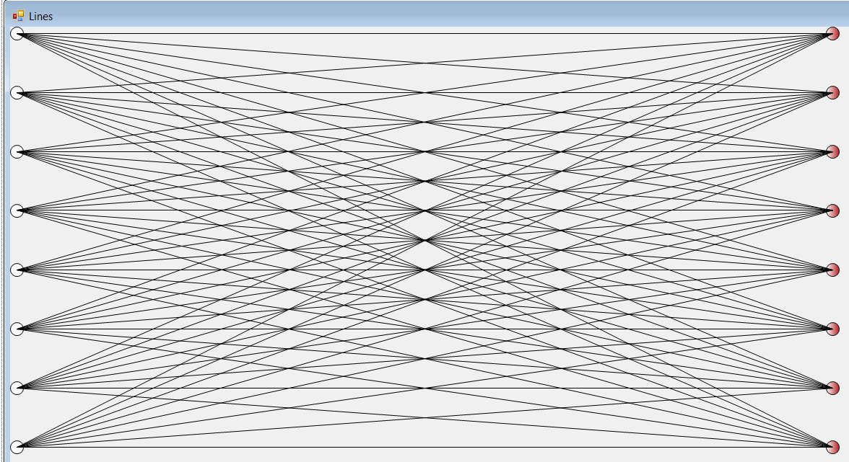

Figure 1: All emitters ON, Effective touch area

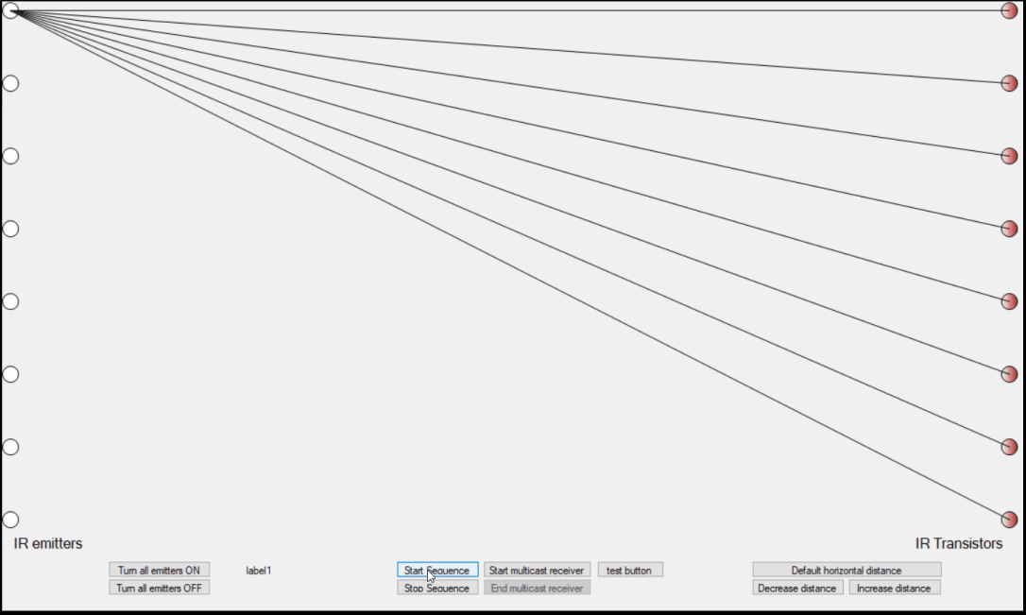

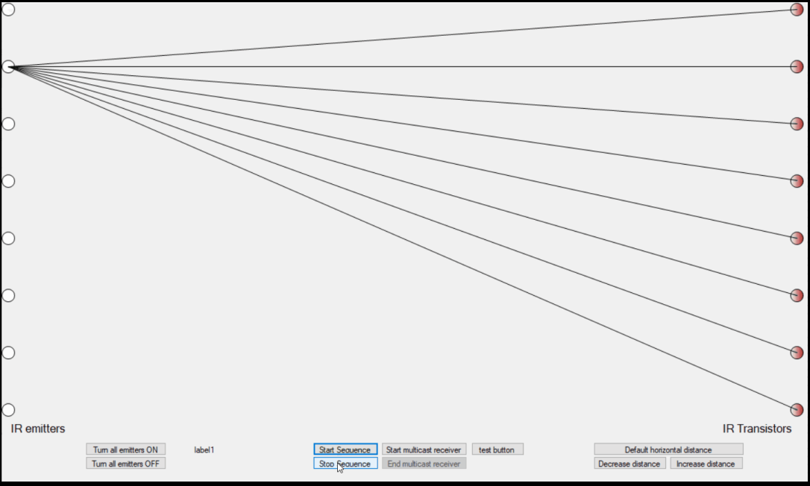

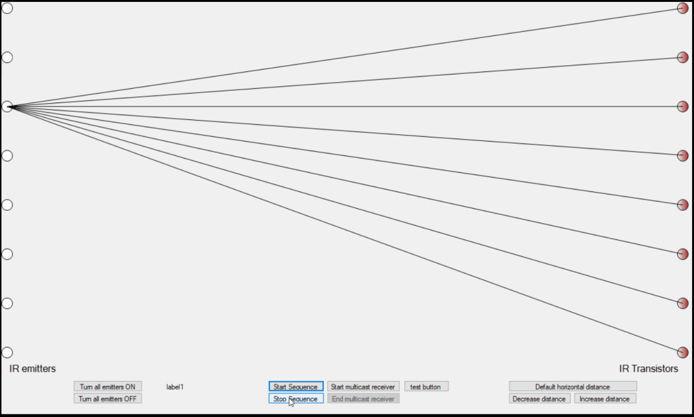

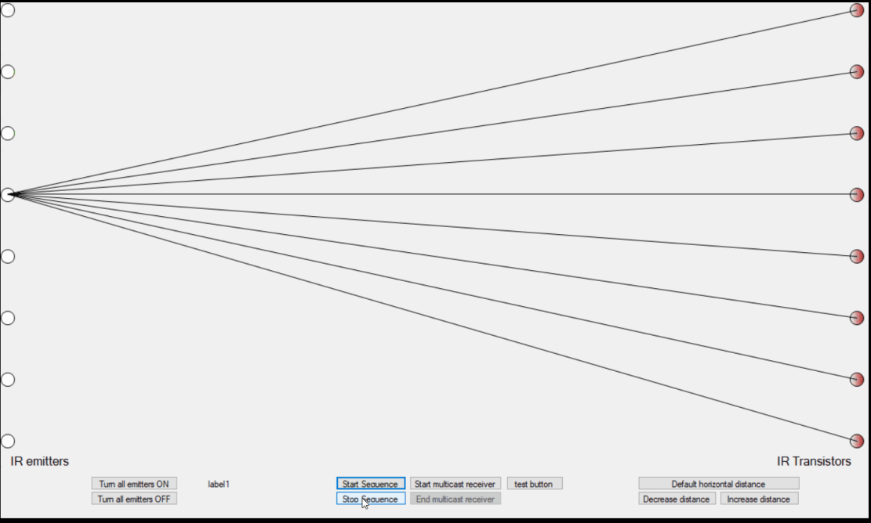

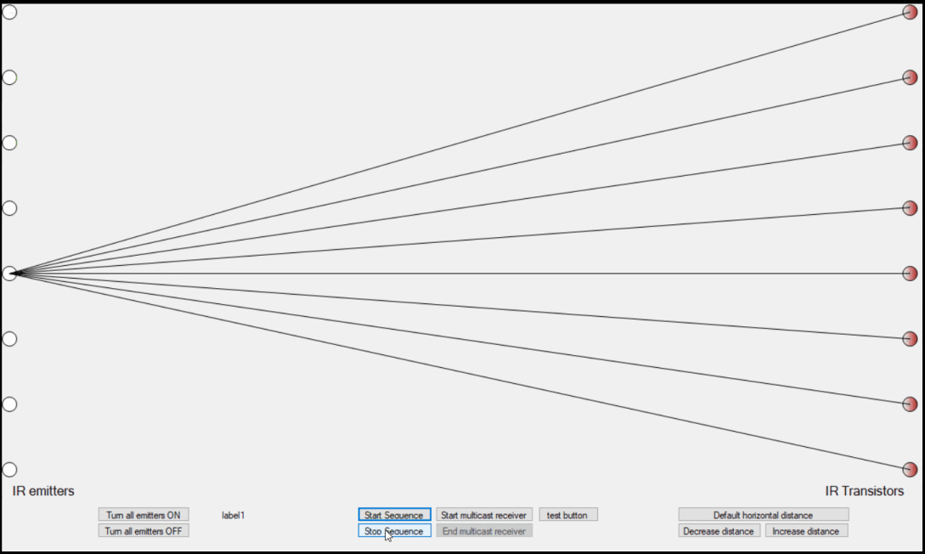

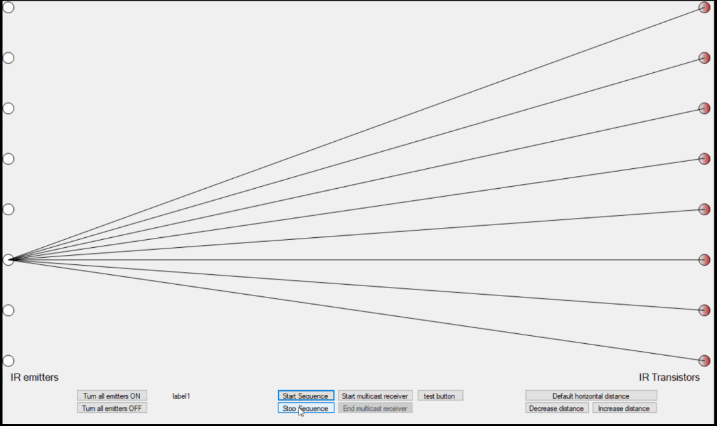

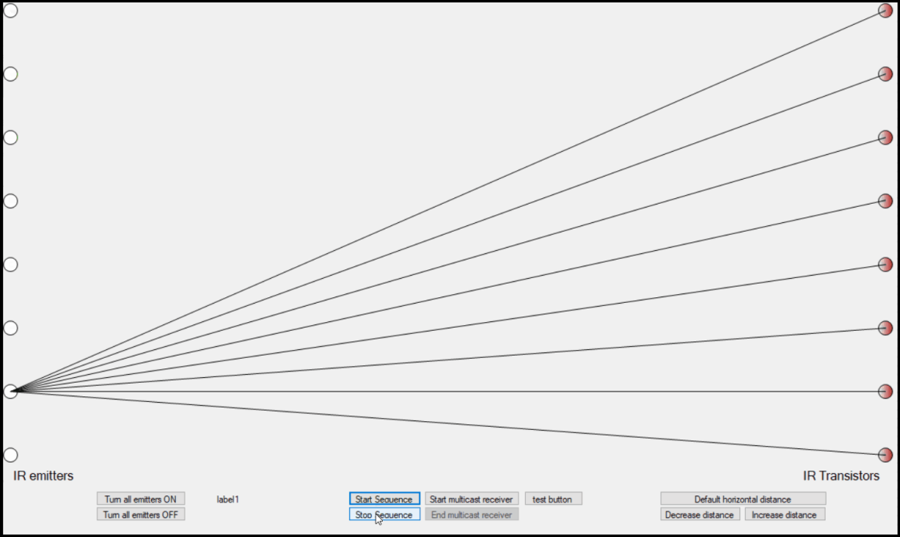

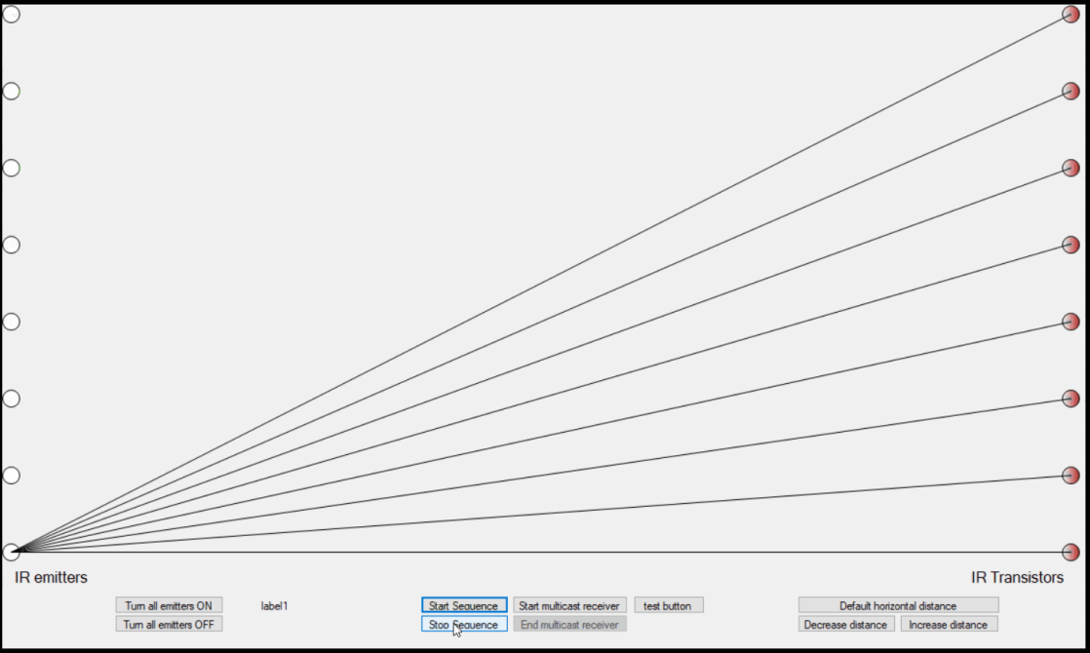

Figures 1.1: General Operation

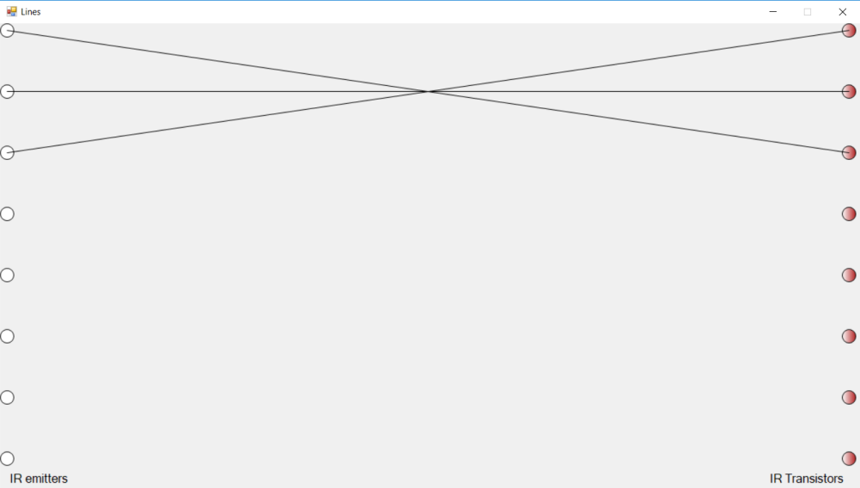

Figure 1.2: Example of an Intercept

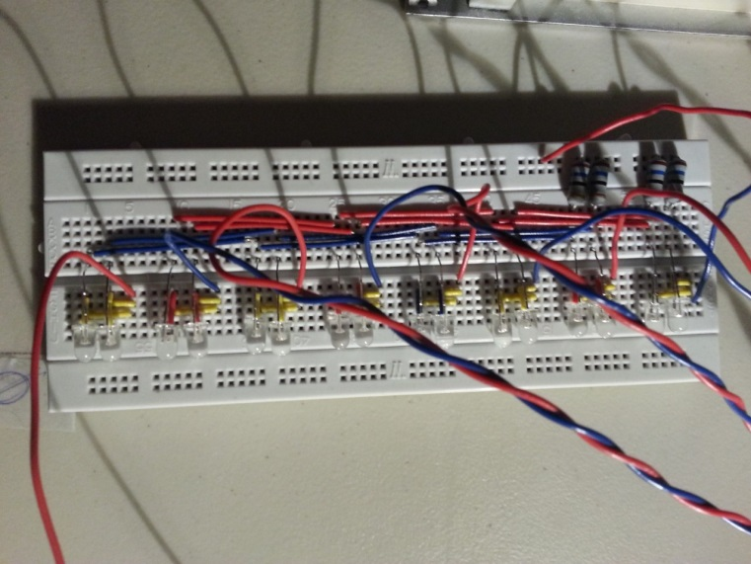

Figure 2: Bread board circuit of the emitter component

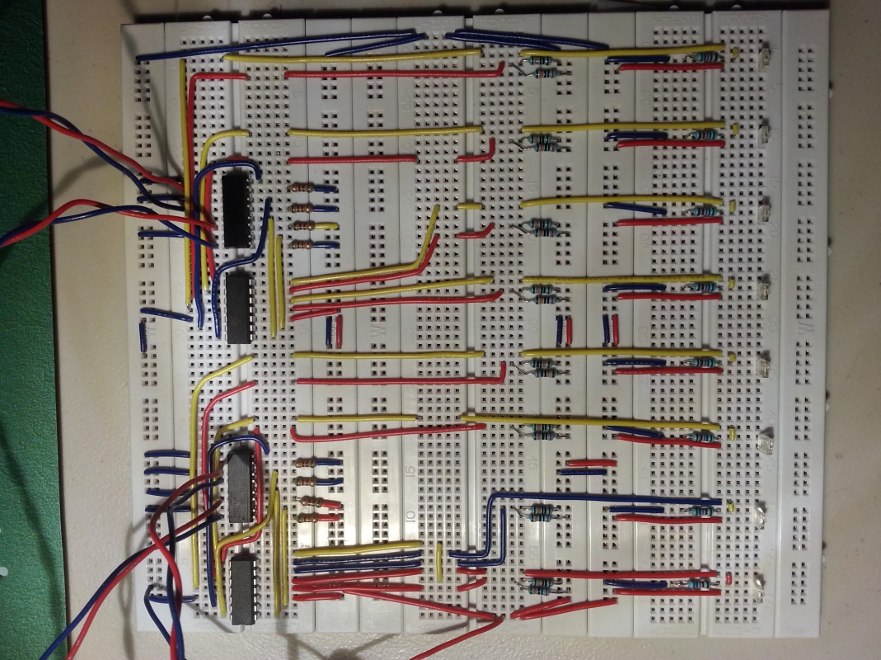

Figure 3: Bread board circuit of the sensor component

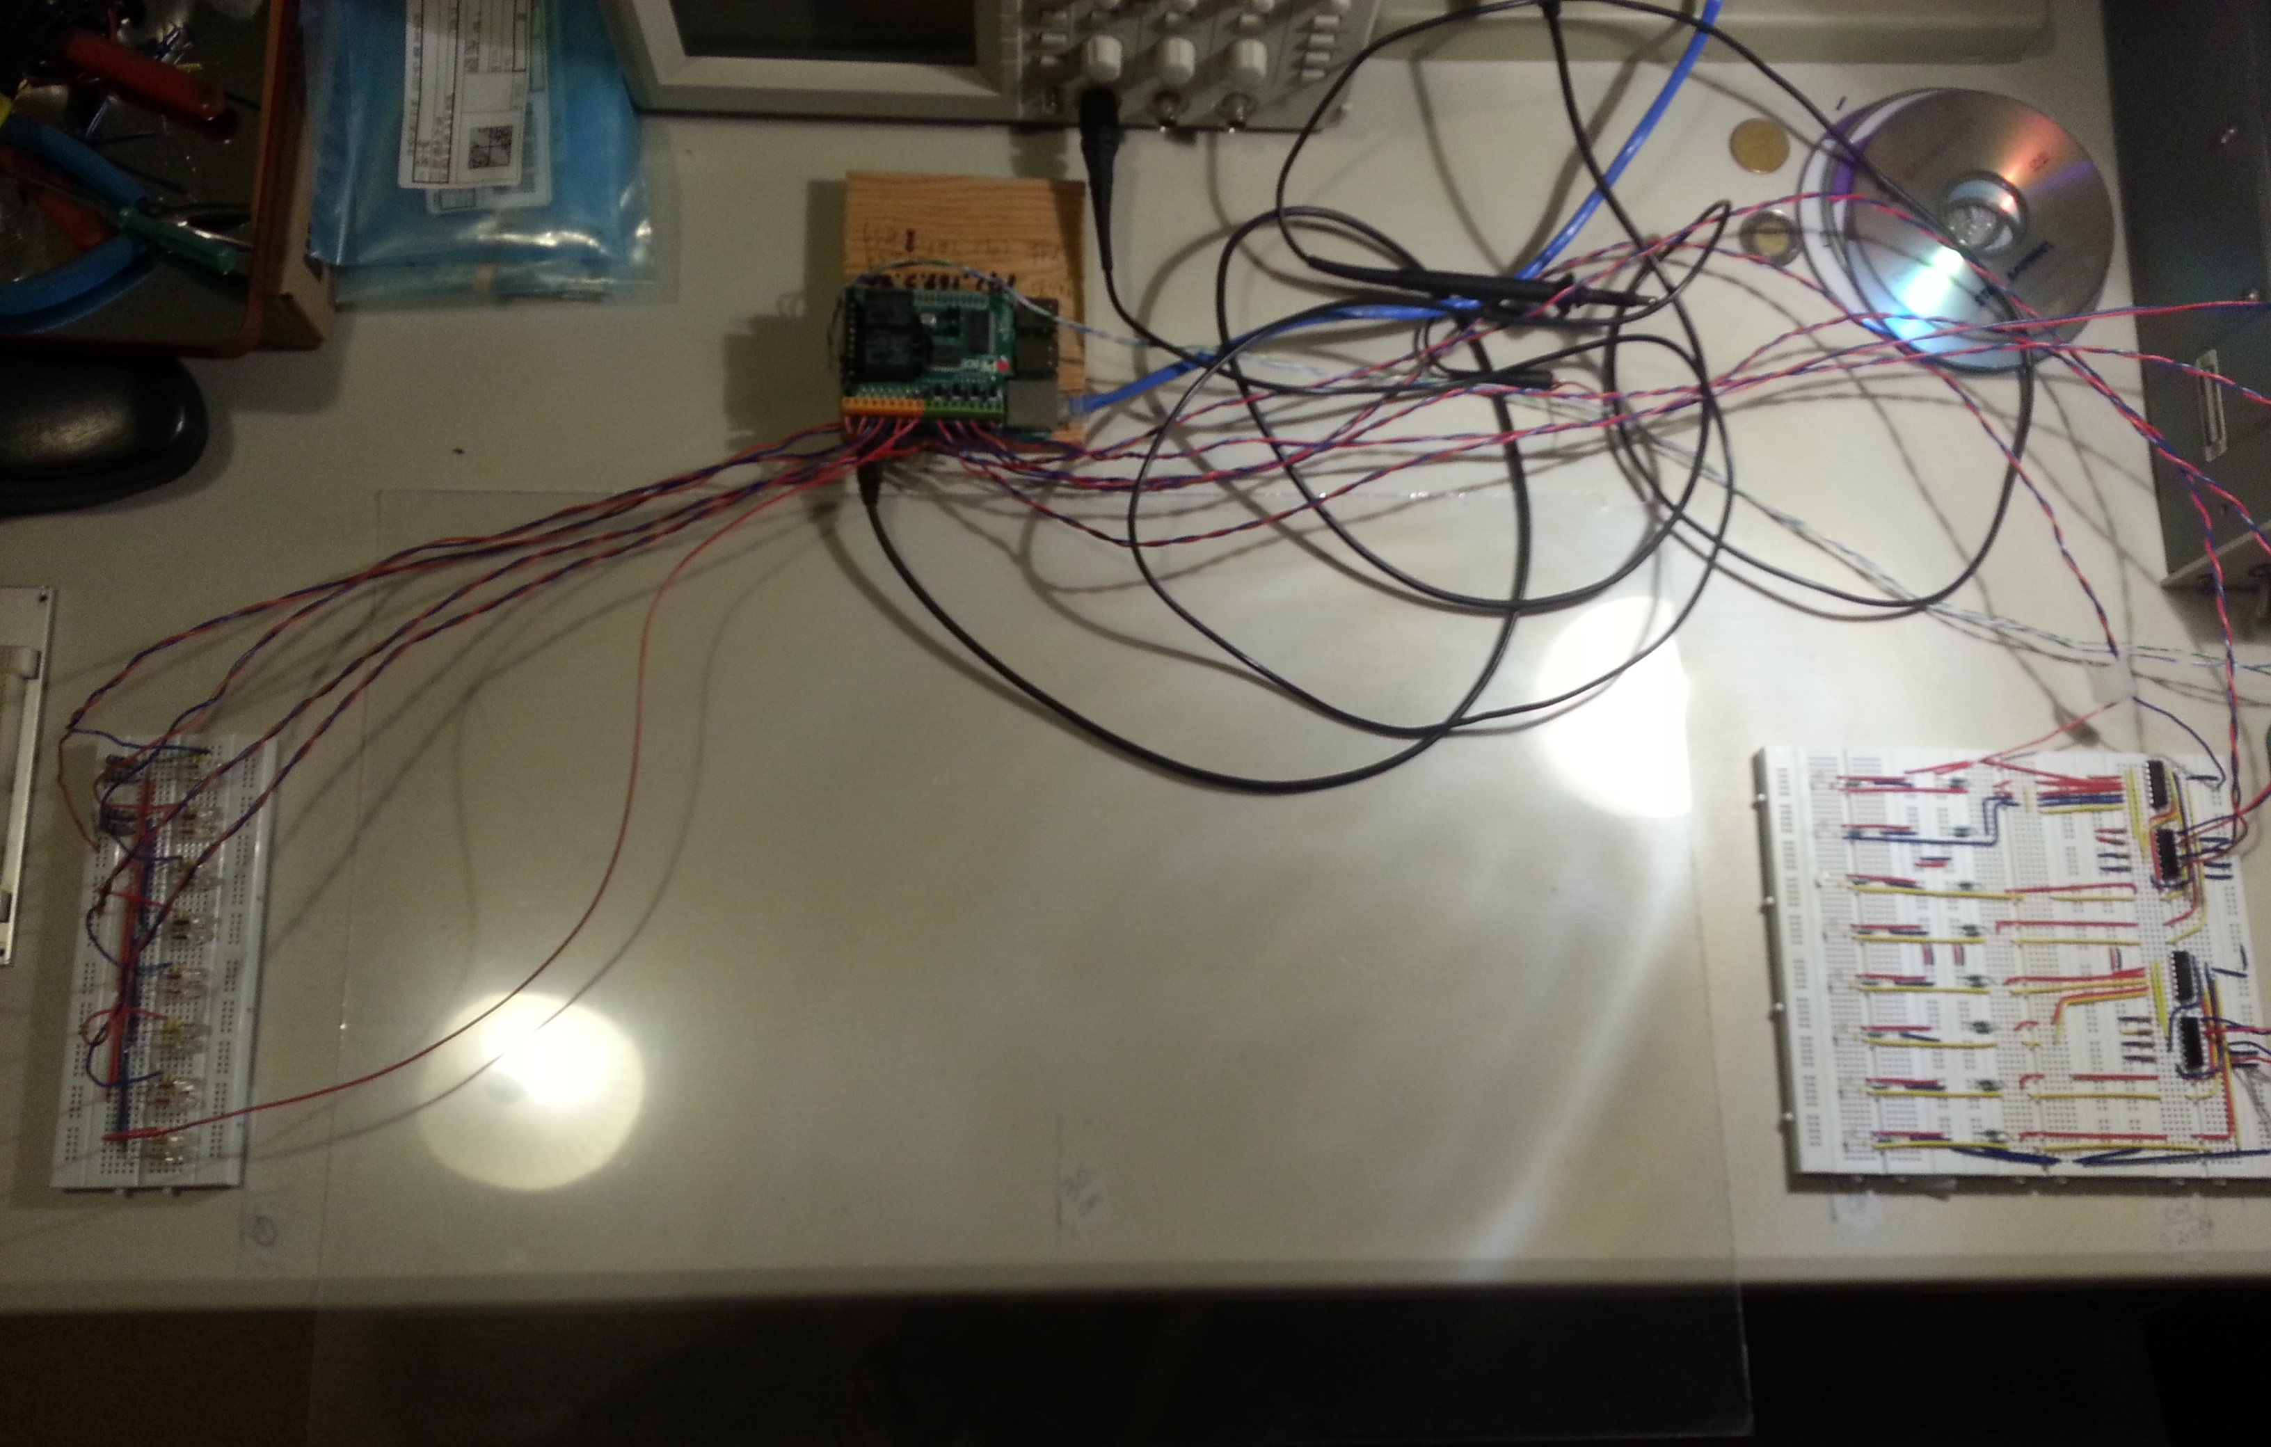

Figure 3.1: Touch screen overlay

Section A.1 Hysteresis add-on

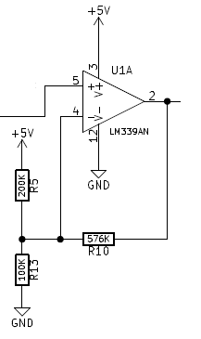

Figure A.1: Hysteresis configuration with a voltage comparator

If a more consistent output voltage is needed that is less affected by the analog’s noise, a hysteresis can be used. A hysteresis in this sense means that the output state depends on the previous outputs. To implement this, 2 voltage thresholds are used to create a range where no change takes place.

To calculate the upper threshold, voltage divider is used:

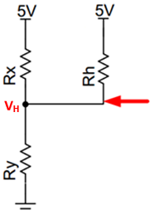Rh is connected to 5V due to $V_{out}$ = 5V for $V_{in}$ > $V_{th}$

$V_{H}$ = $V_{r}$ x $\frac{R_{y}}{(\frac{1}{\frac{1}{R_{x}}+\frac{1}{R_{h}}})+R_{y}}$

$V_{H}$ = 2.7 V

Figure A.2: Upper Threshold visualization

To calculate the lower threshold, the same method is used:

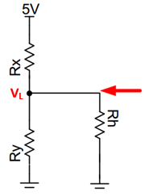Rh is connected to $V_{out}$ = GND for $V_{in}$ < $V_{th}$

$V_{L}$ = $V_{r}$ x $\frac{(\frac{1}{\frac{1}{R_{y}}+\frac{1}{R_{h}}})}{R_{x}+(\frac{1}{\frac{1}{R_{y}}+\frac{1}{R_{h}}})}$

$V_{L}$ = 2.3 V

Figure A.3: Lower Threshold visualization

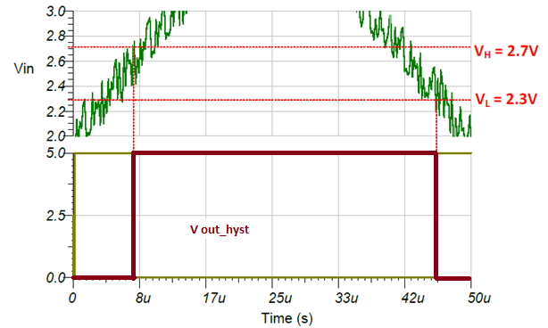

Figure A.4: Output of a Comparator with Hysteresis Showing Single Transition [1]

In figure A.2 it presents that the output voltage transitions to logic HIGH, 5 V, when the input exceeds the upper threshold (VH) and it only transitions to logic LOW, 0 V, when the input is below the lower threshold (VL).

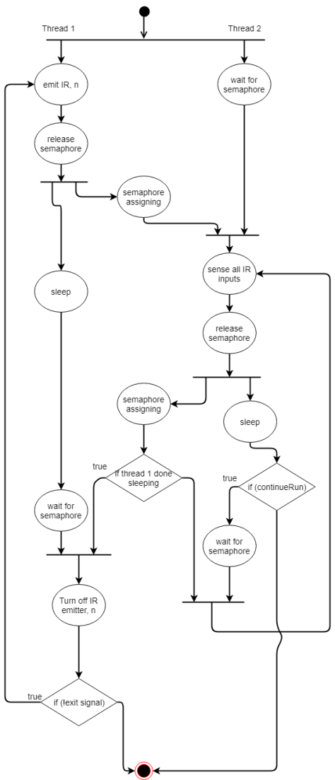

Figure 4: Activity Diagram of hardware control

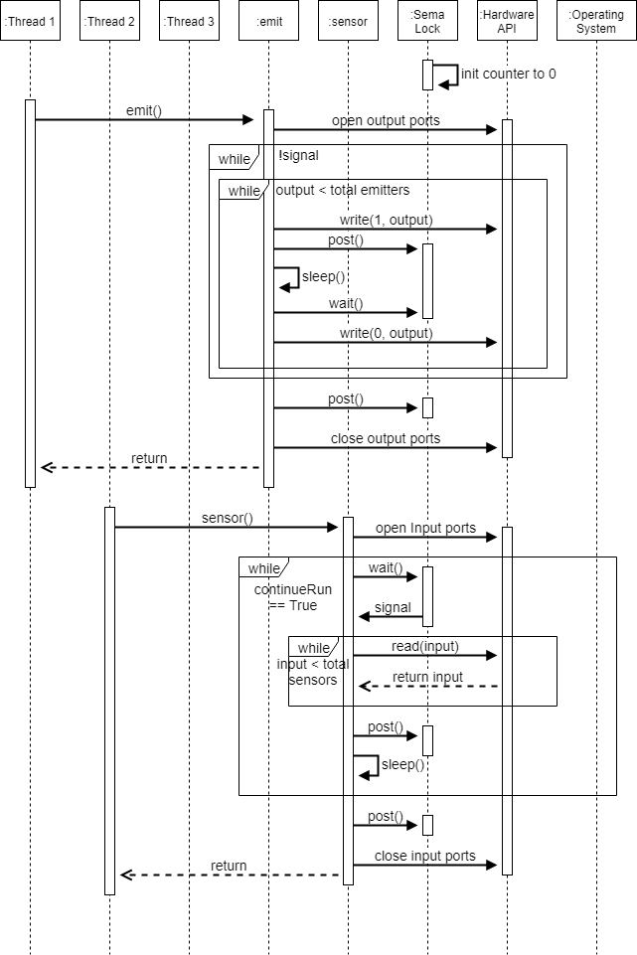

Figure 5: Sequence Diagram of hardware control

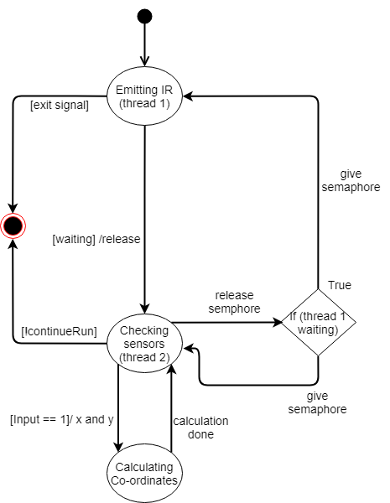

Figure 6: State Diagram for hardware control

|  |  |
| --- | --- |
| Hardware testing methods | Software testing methods |
| 1. Continuity Tests of the circuits  2. Oscilloscope and voltmeter verification   * Manual blocking | 1. Visual confirmation on hardware of correct sequence  2. Stub testing |

Table 2: Testing methods

References

[1] Texas Instruments, “TI Designs – Precision: Verified Design Comparator with Hysteresis Reference Design,” *Texas Instruments*, TIDU020A-May 2013-Revised June 2014. [Online]. Available: <http://www.ti.com/lit/ug/tidu020a/tidu020a.pdf>. [Accessed: March 10, 2018].